Model1

Structural Report

Author: Author

Revision: 0.1

|  |  |
| --- | --- |
|  |  |
|  | Date: November 11, 2015 |

**Table of Contents**

Microsoft Word users please click here and press F9 to create Table of Contents.

OpenOffice.org users please remove this text and select Insert Table of Content from menu.

**Table of Figures**

Microsoft Word users please click here and press F9 to create Table of Contents.

OpenOffice.org users please remove this text and select Insert Table of Content from menu.

# Model1

## Diagram: Model1

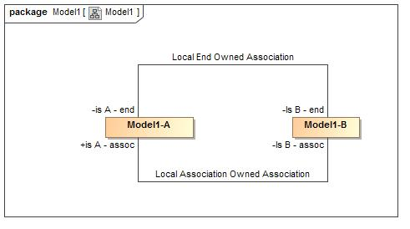

1. Model1

## Association Local Association Owned Association

**package** Model1

### Association Ends

-1903967629.jpg Is B - assoc : Model1-B

-1903967629.jpg is A - assoc : Model1-A

## Association Local End Owned Association

**package** Model1

### Association Ends

-1903967629.jpg Is B - end : Model1-B

-1903967629.jpg is A - end : Model1-A

## Class Model1-A

**package** Model1

### Associations

-1903967629.jpg Is B - end : Model1-B

## Class Model1-B

**package** Model1

### Associations

-1903967629.jpg is A - end : Model1-A

# Tree

## Class Hierarchy